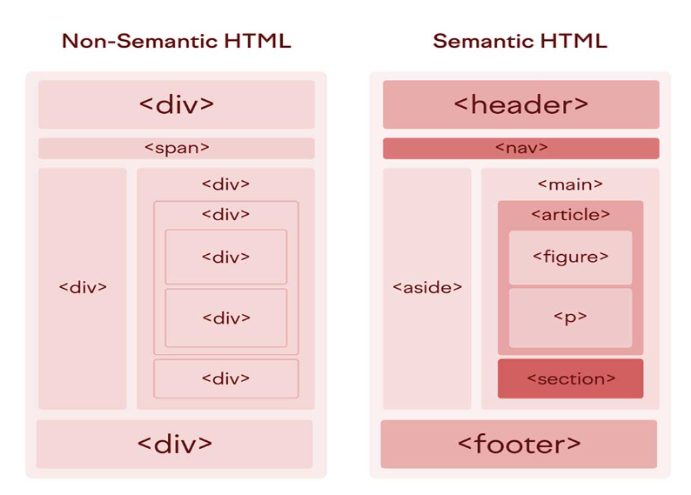

Header

<header>

        <h1>Welcome to My Website</h1>

</header>

Footer

 <footer>

        <p>© 2025 My Website</p>

      </footer>

Nav

<nav>

          <ul>

            <li><a href="#home">Home</a></li>

            <li><a href="#about">About</a></li>

          </ul>

 </nav>

Article

 <article>

        <h2>Article Title</h2>

        <p>This is an article...</p>

      </article>

Section

 <section>

        <h2>Introduction</h2>

        <p>This section introduces the topic...</p>

 </section>

Main

<main>

        <h1>Welcome to the Main Content Area</h1>

        <p>This is where most of the content goes...</p>

</main>

Figure

 <figure>

        <img src="image.jpg" alt="Description of image">

        <figcaption>Image caption here.</figcaption>

 </figure>

Aside

